I tried nonrigid registration. The result for some pair of images was very good. But for some others it was not acceptable.

For example, in group 57, consider first and second images:

C:\Users\Asus\Downloads\BAK9019R_2020_01_28_AOSLO_840_Montage_tempsup_Vgl_HMM\BAK9019R_2020_01_28_AOSLO_840_Montage_tempsup_Vgl_HMM\New folder\MyStitch\4_5812040063814469275\BAK9019R_2020_01_28_11_41_59_AOSLO_840_V001_stabilized_aligned_to_ref2_m1.tif C:\Users\Asus\Downloads\BAK9019R_2020_01_28_AOSLO_840_Montage_tempsup_Vgl_HMM\BAK9019R_2020_01_28_AOSLO_840_Montage_tempsup_Vgl_HMM\New folder\MyStitch\4_5812040063814469275\BAK9019R_2020_01_28_11_42_29_AOSLO_840_V002_stabilized_aligned_to_ref2_m1.tif

Figure -left: image 1, group 57. Right: image 2, group 57

For better visualization, I put both of them in one frame:

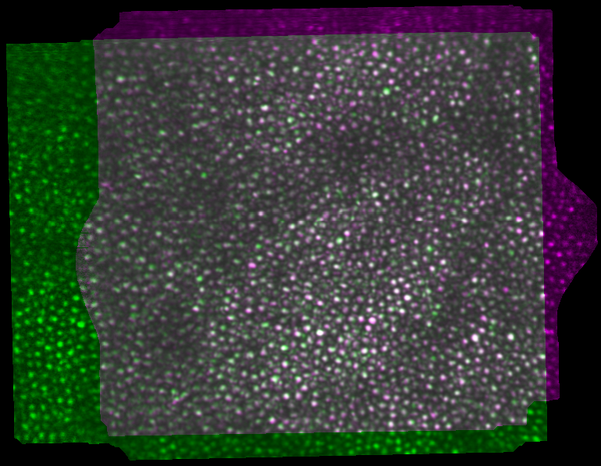

Figure - the overlay view of image 1 and image 2 in group 57. The magenta parts are for image 1, the green parts are for image 2, and the overlapping area is shaded gray.

It is obvious from Figure 2 that these two images match very good.

The result of nonrigid registration (image 1 to image 2), after 100 and 200 iterations are:

C:\Users\Asus\Downloads\BAK9019R_2020_01_28_AOSLO_840_Montage_tempsup_Vgl_HMM\BAK9019R_2020_01_28_AOSLO_840_Montage_tempsup_Vgl_HMM\New folder\MyStitch\4_5812040063814469275\nonrigid_1_2_57_100_0.991.tif C:\Users\Asus\Downloads\BAK9019R_2020_01_28_AOSLO_840_Montage_tempsup_Vgl_HMM\BAK9019R_2020_01_28_AOSLO_840_Montage_tempsup_Vgl_HMM\New folder\MyStitch\4_5812040063814469275\nonrigid_1_2_57_200_0.991.tif

Figure -the results of nonrigid registration. Left: after 100 iterations (about 3 minutes). Right: after 200 iterations (about 6 minutes).

The quality that was reported by the application for these 100 iterations and 200 iterations was 0.991. Also, visually I think the result is good, except than the edges that we can remove.

Now consider image 22 and image 27 in group 57:

C:\Users\Asus\Downloads\BAK9019R_2020_01_28_AOSLO_840_Montage_tempsup_Vgl_HMM\BAK9019R_2020_01_28_AOSLO_840_Montage_tempsup_Vgl_HMM\New folder\MyStitch\4_5812040063814469275\BAK9019R_2020_01_28_12_02_18_AOSLO_840_V022_stabilized_aligned_to_ref2_m1.tif C:\Users\Asus\Downloads\BAK9019R_2020_01_28_AOSLO_840_Montage_tempsup_Vgl_HMM\BAK9019R_2020_01_28_AOSLO_840_Montage_tempsup_Vgl_HMM\New folder\MyStitch\4_5812040063814469275\BAK9019R_2020_01_28_12_04_07_AOSLO_840_V027_stabilized_aligned_to_ref2_m1.tif

Figure -left: image 22, group 57. Right: image 27, group 57

And again for better visualization, we can look at overlay image:

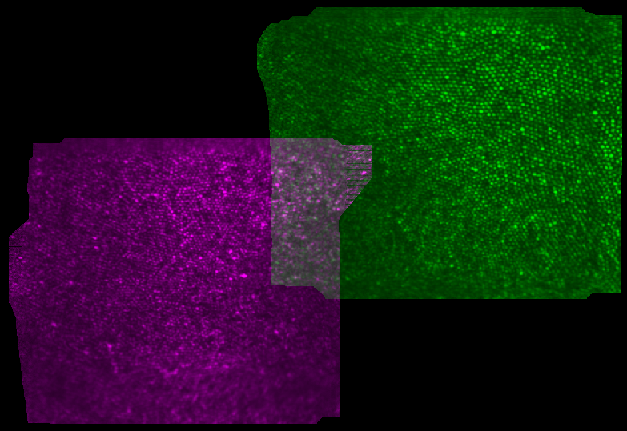

Figure - the overlay view of image 1 and image 2 in group 57. The magenta parts are for image 1, the green parts are for image 2, and the overlapping area is shaded gray.

I think from this overlay image we can conclude visually that these two images don’t match as good as images 1 and 2. However, it is better to continue the process and see the result.

The result of nonrigid registration (image 22 to image 27), after 100 iterations is:



Figure -the results of nonrigid registration after 100 iterations (about 3 minutes).

The quality that was reported by the application for 100 iterations was 0.958. Here, visually I think the result is not good. I zoomed in the overlapping region:



Figure -the overlapping area zoomed for better visualization.

Now, another example: image 22 and image 23

C:\Users\Asus\Downloads\BAK9019R_2020_01_28_AOSLO_840_Montage_tempsup_Vgl_HMM\BAK9019R_2020_01_28_AOSLO_840_Montage_tempsup_Vgl_HMM\New folder\MyStitch\4_5812040063814469275\BAK9019R_2020_01_28_12_02_18_AOSLO_840_V022_stabilized_aligned_to_ref2_m1.tif C:\Users\Asus\Downloads\BAK9019R_2020_01_28_AOSLO_840_Montage_tempsup_Vgl_HMM\BAK9019R_2020_01_28_AOSLO_840_Montage_tempsup_Vgl_HMM\New folder\MyStitch\4_5812040063814469275\BAK9019R_2020_01_28_12_02_35_AOSLO_840_V023_stabilized_aligned_to_ref2_m1.tif

Figure -left: image 22, group 57. Right: image 23, group 57

And again for better visualization, we can look at overlay image:

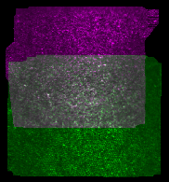

Figure - the overlay view of image 1 and image 2 in group 57. The magenta parts are for image 1, the green parts are for image 2, and the overlapping area is shaded gray.

I think from this overlay image we can conclude visually that these two images don’t match as good as images 1 and 2, but match better than image 22 and 27. So, we can check this.

The result of nonrigid registration (image 22 to image 23), after 100 iterations is:



Figure -the results of nonrigid registration after 100 iterations (about 3 minutes).

I think the result is not good enough. Specially the area in the red square. I saved all results by a name explaining its features. For example, “nonrigid\_22\_24\_57\_100\_0.965” means nonrigid registration between images 22 and 24 of group 57, after 100 iterations, with resulted quality of 0.965.

I wanted to put a threshold on quality of the result and refuse the results lower than a threshold. But unfortunately, this application doesn’t give access to the quality of the results when generating codes. So, I computed correlation coefficient between overlapping areas in the first image and the second image to find a pattern.

|  |  |  |  |  |
| --- | --- | --- | --- | --- |
| Number of first image | Number of second image | Quality reported by App | Cross correlation | Acceptable |
| 1 | 2 | 0.991 | 0.9807 | Yes |
| 22 | 27 | 0.958 | 0.9529 | No |
| 22 | 23 | 0.975 | 0.9730 | No |
| 1 | 3 | 0.975 | 0.9503 | No |
| 2 | 3 | 0.979 | 0.9655 | No |
| 22 | 23 | 0.965 | 0.9463 | No |

So, it seems that the quality reported by App and cross correlation have straight relation; when one of them increases the other one increases too. Also, it seems that cross correlations less than 0.98 are not acceptable. However, most of our mages have cross correlation less than this value. So, I tried to solve the problem. There are other image registration techniques:

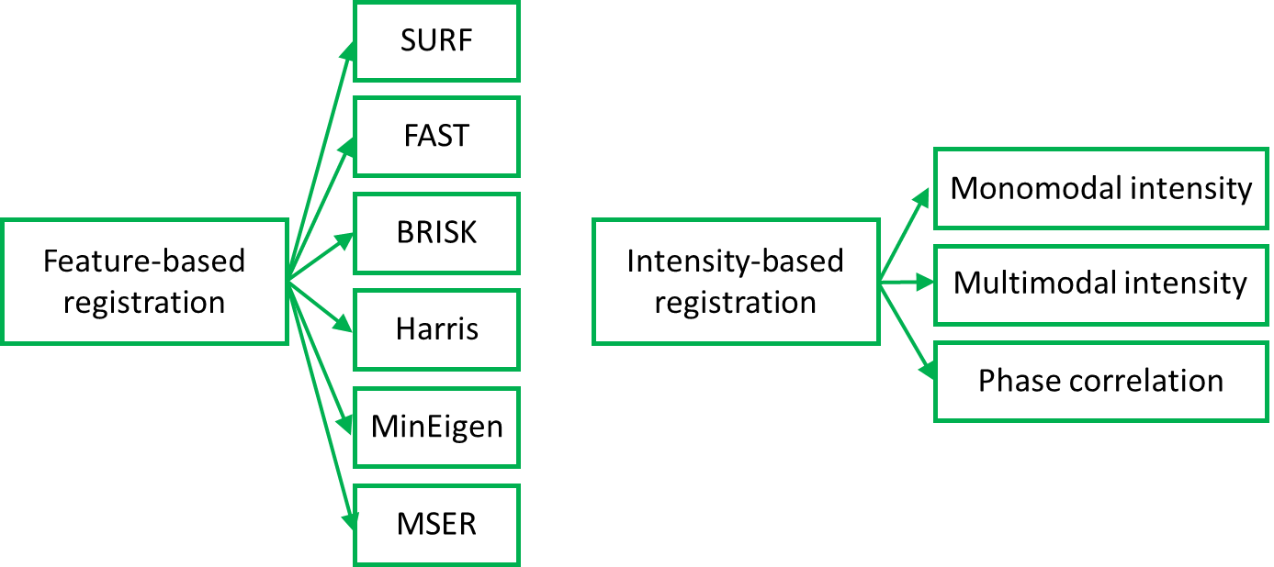

Figure -different types of image registration.

We can apply any of these image registration techniques in combination with nonrigid registration. The second class (intensity-based registration) is not suitable for our work because they work based on pixel wise intensity and don’t consider image structure that I think is very important to us.

To make sure about this idea, I tried one of them. Here are the results with and without nonrigid registration.

 

Figure -result of phase correlation registration. Left: without nonrigid registration (after about 90 seconds). Right: with nonrigid registration.

Maybe the results don’t seem such bad with eye. But, there is a problem. Here is the overlay image before registration, and after registration:

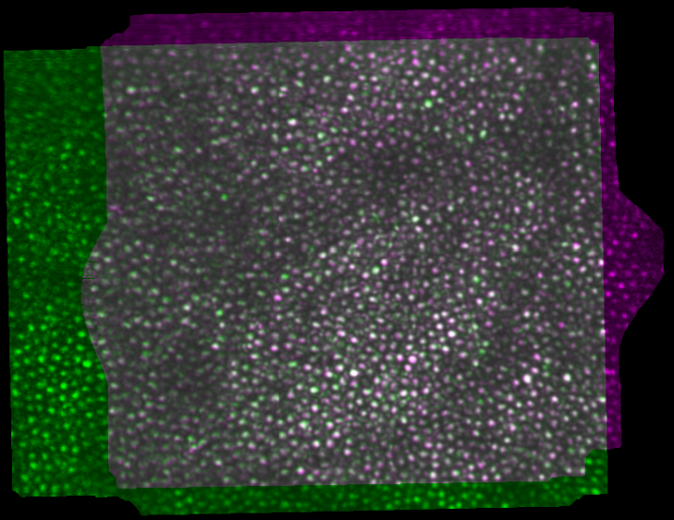 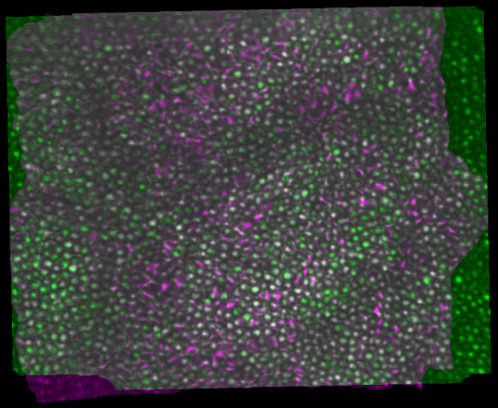

Figure -overlay view for image 1 and image 2. Left: before registration. Right: after registration.

In Figure 13 we can see that images are dilated that is not good.

There are also two other problems: 1) I am not sure, but I think the basis of these techniques is optical flow. And in registration based on optical flow, if the average intensity of two images is not equal, the registration is impossible. Therefore, the first step in such techniques is something like histogram equalization. This ruins the images when one of the images is significantly darker or lighter that the other (like our images in FOVEA). The other problem is that for most of our images these techniques are not able to register images. However, since the results are not acceptable, it is not important anymore.

Now, we try some feature-based techniques. In these techniques, first step is feature extraction. Here is the image showing matched points in image 1 and 2 in group 57:

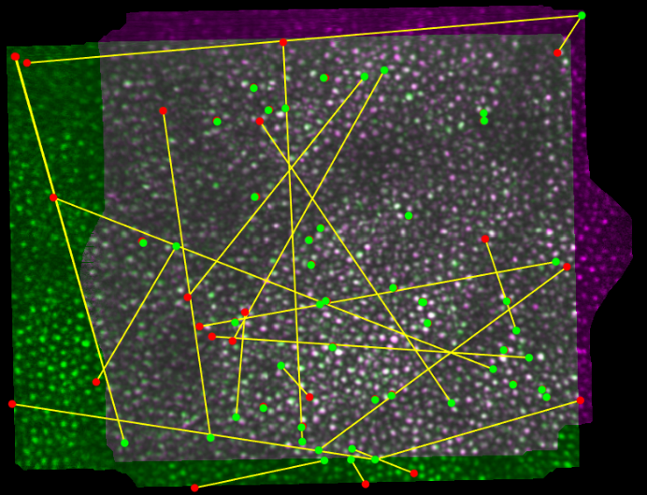

Figure -overlay view for image 1 and image 2 with matched points on it.

The matched points are not good at all, but we can change the criteria. I increased threshold quality of matched features from 50 to around 70 percent (the exact value is not available by the gui).

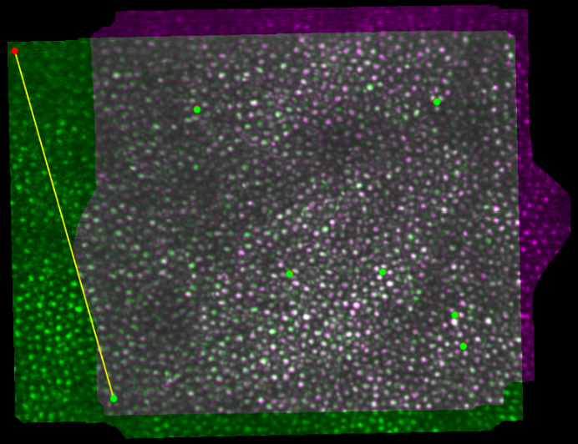

*Figure 15-overlay view for image 1 and image 2 with matched points on it (threshold increased to 70 %).*

The number of matched points is decreased to seven. But, they seem more rational. Now, here is the result of registration with and without nonrigid registration. The registration without nonrigid was very fast (only 0.43 seconds).

 

Figure -result of SURF registration. Left: without nonrigid registration (after about 0.43 seconds). Right: with nonrigid registration (after about 3 minutes).

The results in Figure 16 (right) are very close to the results that we obtained using only nonrigid registration. I think it is because SURF is close to the algorithm that AUTOMANTAGING uses for image registration. SURF also finds some similar areas in two input images and finds the best transformation between these areas and then applies this transformation on the whole image, just like constellation algorithm. The other feature-based techniques made similar results, with some little differences. Therefore, I tried to stick on SURF and test it on the other images. Here is the overlay image for image 22 and image 27. The matched features are shown on this image.

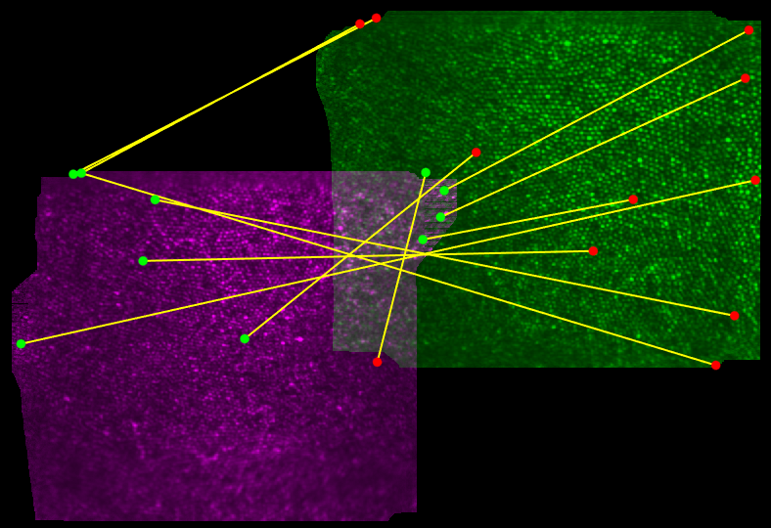

Figure -overlay view for image 22 and image 27 with matched points on it.

In Figure 17 we can see that no matching pair is found on the overlapping region. Also, the other matched pairs are not promising, I think. There is no way to be an acceptable match between for example upper left corner of image 22 and upper left corner of image 27. I wanted to test this idea and as we were expecting, it is not possible to find a transformation that works for all matched pairs:



I tried to increase the threshold of quality for matching. But, there were two problems. The more important one was that increasing this threshold causes we find no match between some images (e.g. image 22 and 27), and unfortunately most of our images have the same situation. Even if we want to apply this algorithm locally, we will have this problem. The other problem is that it is not possible to find the best threshold automatically. At least I couldn’t find a way. I tried different threshold for each pair and tried to visually find out which threshold makes the best results.